Story

Date | 24 September 2024
Team ID | PNT2022TMIDxxxxxx
Project Name | Title
Maximum Marks | 5 Marks

Activity 1: Story Design:

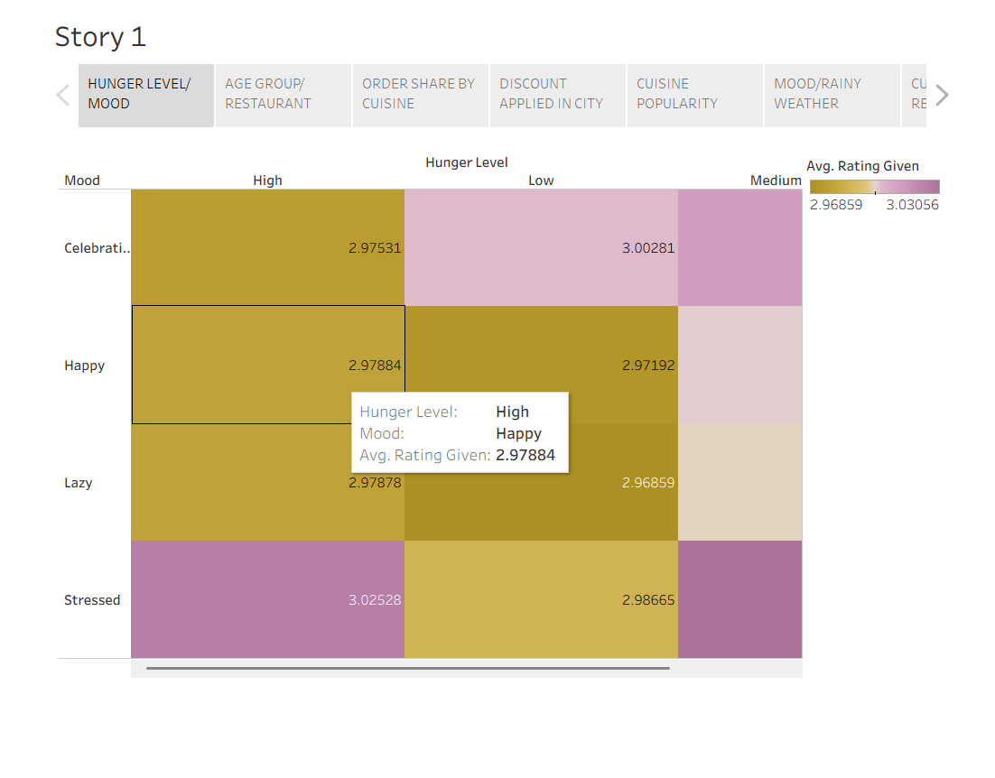
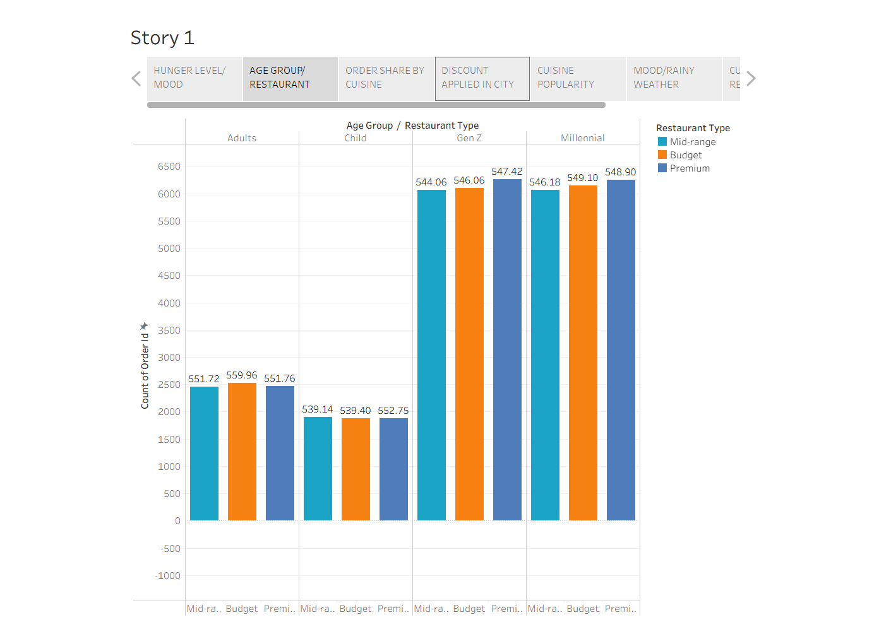
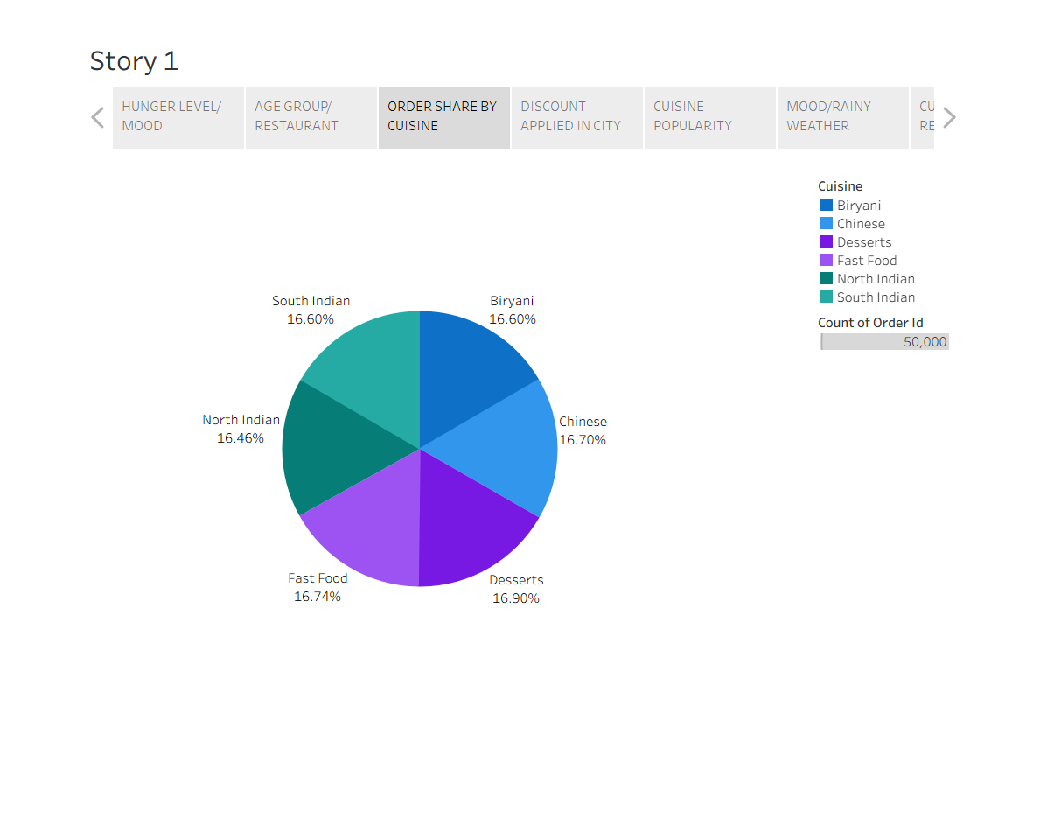
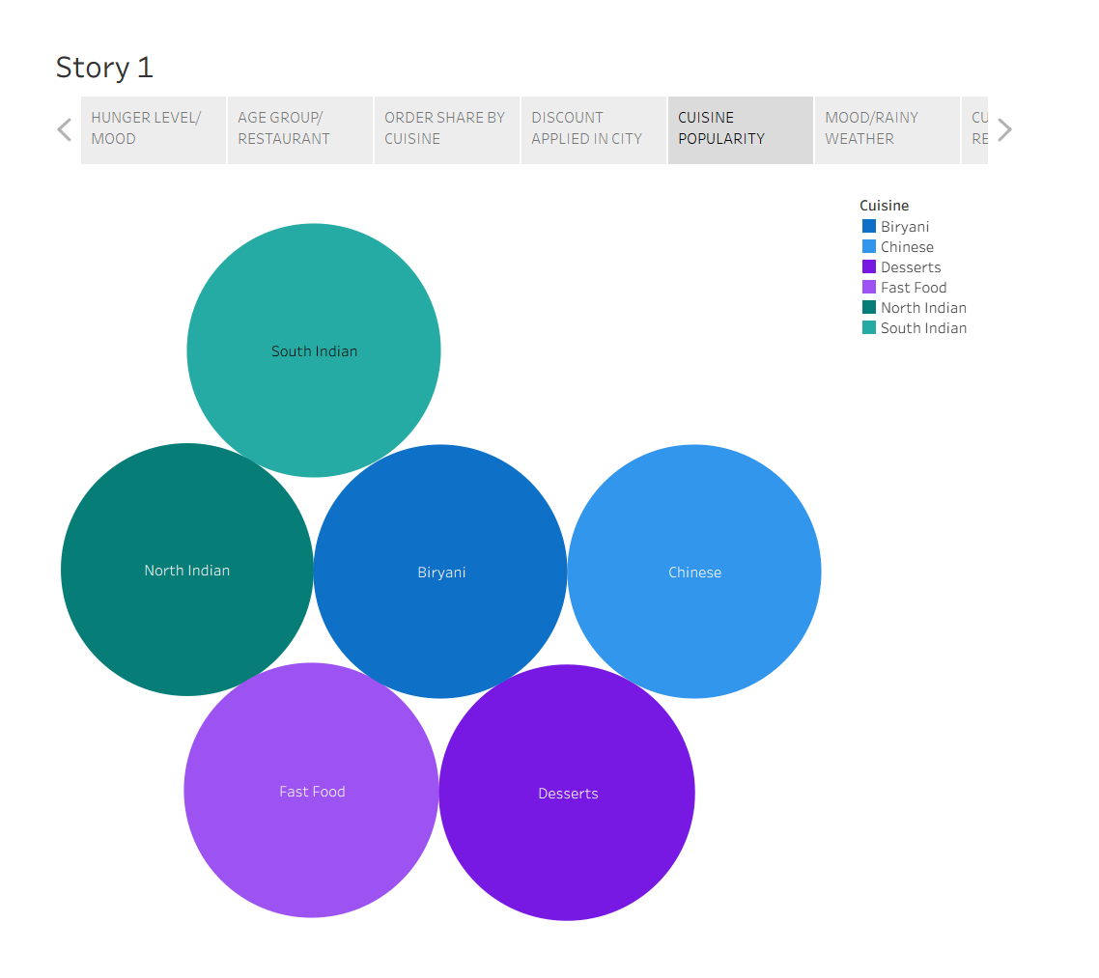
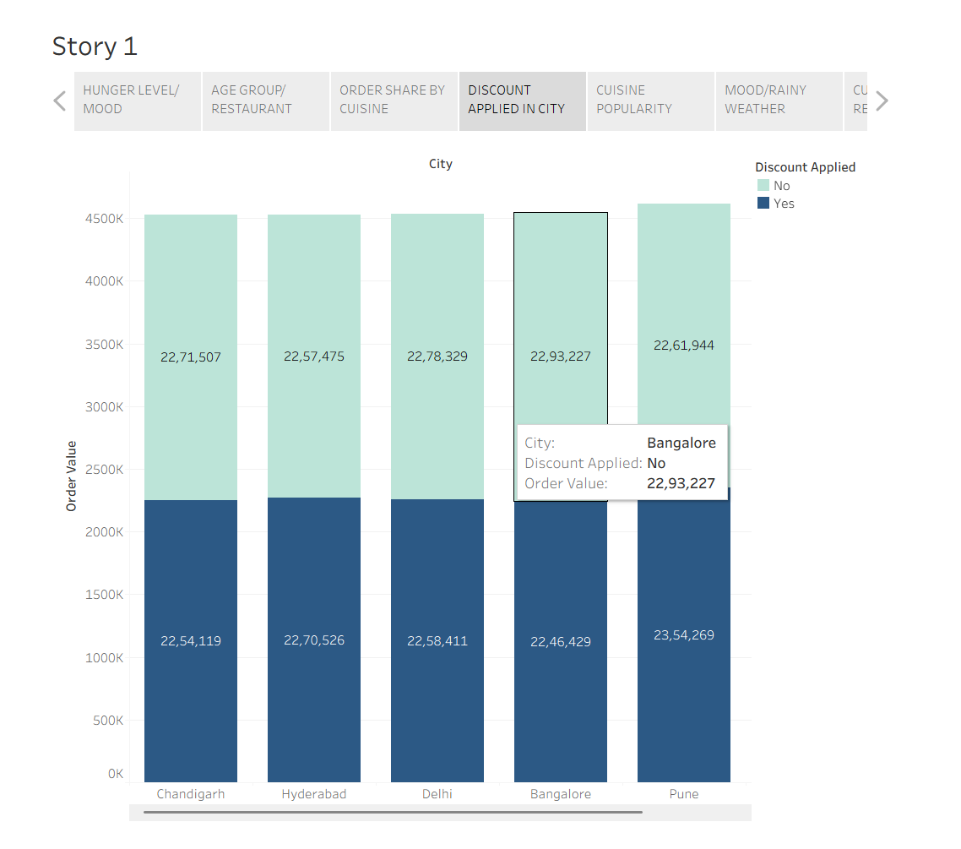
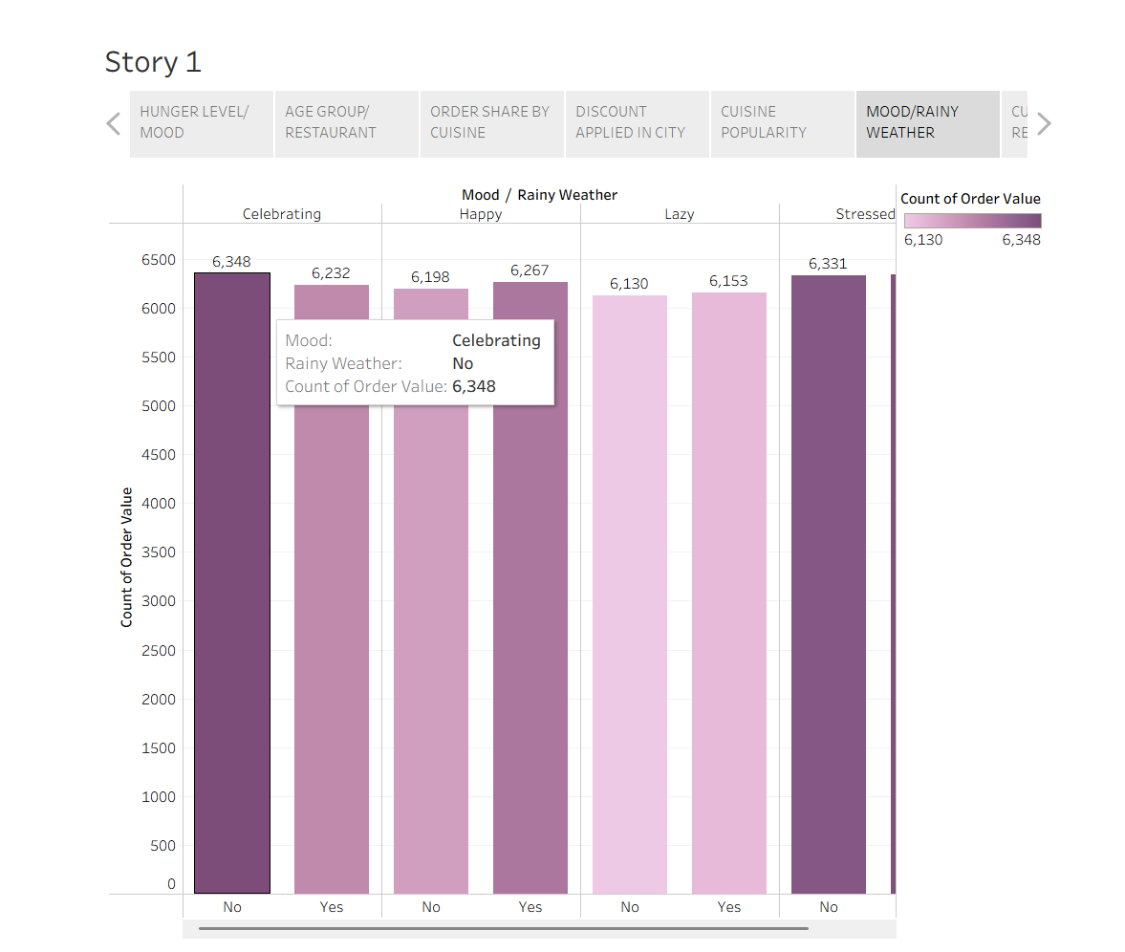

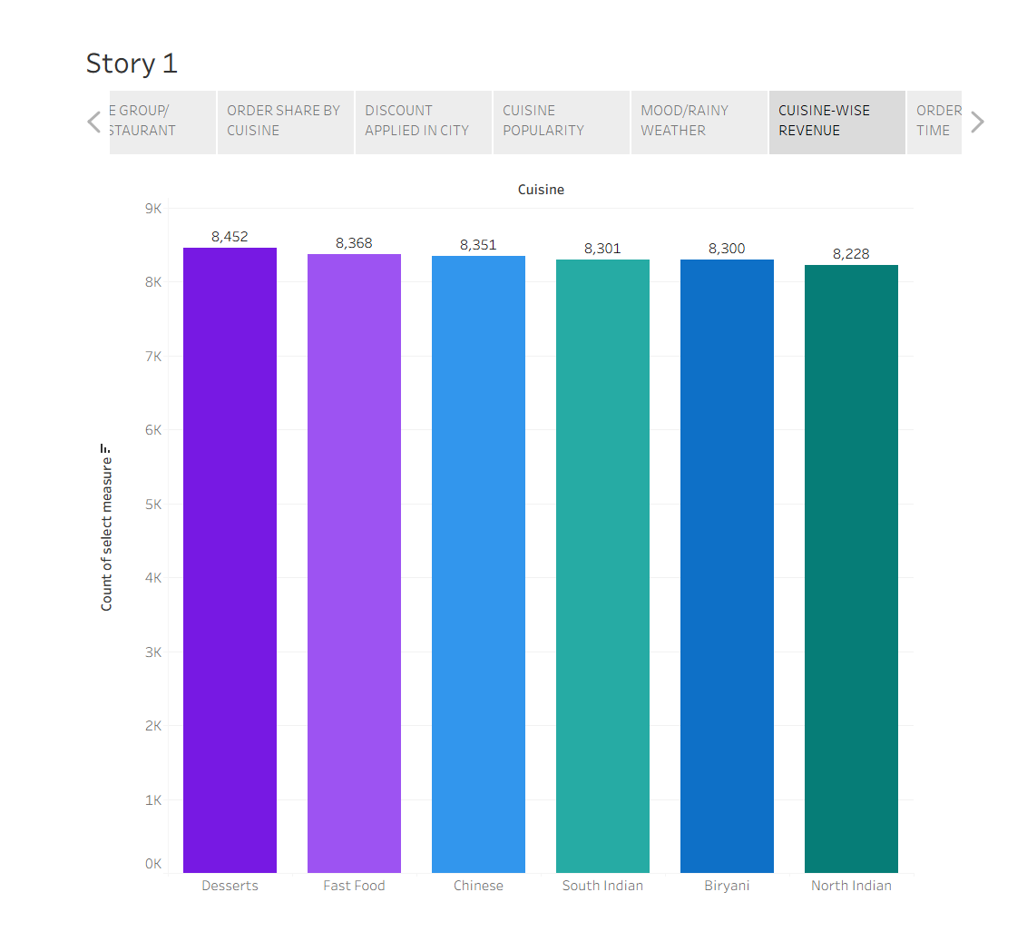

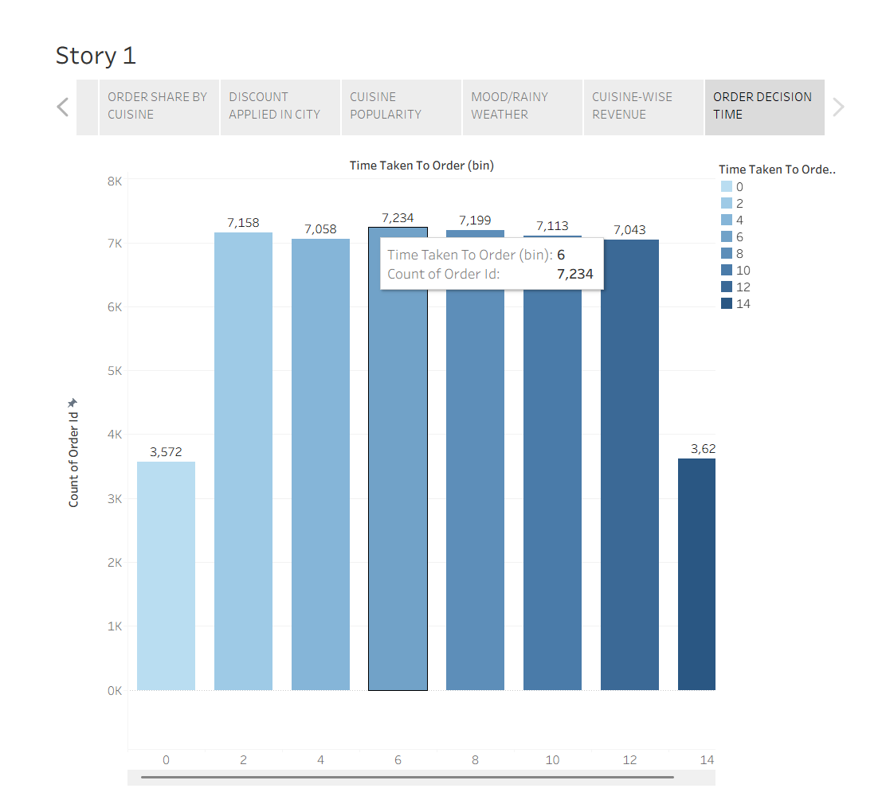

Tableau Story Narrative & Observations
By leveraging the sequential story point structure in Tableau, the HeartScope Food Delivery Consumer Behavior analytical presentation guides stakeholders through a logical progression of marketplace metrics, turning raw transaction logs into a cohesive behavioral narrative.
Based on the interactive story points, here are the core business observations:
- Marketplace Scale & Revenue Generation (KPI Demonstration): The initial summary metrics establish the overall platform volume—showcasing a total delivery fee earning of ₹2.98M, an aggregate order value of ₹27.39M, an average customer rating of 3, and a total order volume of 50,000 to frame the baseline scale of the ecosystem.

- Demographic Concentration Across Restaurant Tiers (Orders by Age Group and Restaurant Type): The grouped bar visualization reveals that transaction volumes are heavily concentrated within younger demographic segments like Gen Z and Millennials across Budget, Mid-range, and Premium restaurant tiers. This highlights primary user cohorts for targeted platform marketing.

- Visual Clustering of Urban Spending & Promotions (Order Value by City and Discount Usage): The stacked bar chart demonstrates a uniform baseline of total order values across metropolitan hubs (Bangalore, Chandigarh, Delhi, Hyderabad, Mumbai, Pune), clearly illustrating how promotional discounts scale across urban markets.

- Behavioral & Environmental Demand Shifts (Order Count by Mood and Rainy Weather): The comparative bar analysis confirms a noticeable surge in order frequencies when specific consumer emotional states (such as Celebrating or Stressed) interact with environmental conditions like rainy weather, highlighting key external demand drivers.

Activity 2:
Publish Story on Tableau Public and Paste Public link below:
TABLEAU STORY 1
Web Deployment URL
https://heartscope-bnrj.onrender.com/

